Requirements/Design Specification

**Feb2015 Competitor Changes**

Revision History

|  |  |  |  |
| --- | --- | --- | --- |
| **Date** | **Revision** | **Description** | **Author** |
| 2/23/2015 | 1.0 | Initial Version with Requirements | Roger Behm |
| 3/2/2015 | 1.1 | Updated lost changes after hard drive failure | Roger Behm |
|  |  |  |  |
|  |  |  |  |
|  |  |  |  |

The information furnished herein by Republic Services Inc. is proprietary and confidential to Republic Services Inc. personnel and is not to be duplicated, published, or disclosed to any third party in whole or in part without permission from Republic Services, Inc.

© Copyright 2012, Republic Services Inc. - All rights reserved.

Table of contents

1 Business Requirements 6

1.1 Purpose of the Design Specification 6

1.1.1 Bug list for current release 6

2 Competitor Overview and Assumptions 6

3 Design 8

3.1 #426 Competitors missing for Area 49BU 454 Salt Lake City 8

3.2 #421 Area 03 Div 3211 need competitor Sanico (SAO) to be added 8

3.3 #417 Competitors not in Dropdown list for Area 08 9

3.4 #415 Competitors missing in Capture for Area 38 9

4 InfoPro Interface 10

5 Report Changes 10

6 Appendix 10

# Business Requirements

## Purpose of the Design Specification

This document highlights items to be fixed and implemented for the titled release.

### Bug list for current release

| GitHub Item  Number | **Description** |
| --- | --- |
| 426 | Competitors missing for Area 49BU 454 Salt Lake City |
| 421 | Area 03 Div 3211 need competitor Sanico (SAO) to be added |
| 417 | Competitors not in Dropdown list for Area 08 |
| 415 | Competitors missing in Capture for Area 38 |
|  |  |

# 

# Competitor Overview and Assumptions

Every competitor must be manually added in to that list, and then a constraint added or modified to filter it . All competitors need to be in the placemats in order for them to make it to the Area_Competitors and div_competitor_adj tables. There are three sections in Capture that display a competitor dropdown menu.

* The new Quote - New/Competitor dropdown displays the competitor_quote attribute, filtered by Area.
* The final page competitor dropdown is also populated from the competitor_quote attribute, like on the first page of a quote however it is not filtered by division
* For rollback due to competitive bid, the competitor list from there is in a dropdown (competitor) in config.  This is the only competitor that can affect pricing.

All competitors must be in that dropdown list (add menu items), and there is a constraint called ‘Constrain Competitor Based on area_quote’ that does a competitor lookup by area from the Area_Competitors table. Here are the steps to manually add a competitor

1. Check that the competitor is in the global Competitor list (Menu)

Go to Process Definition, Documents, Quote Attributes, List and open the competitor_quote attribute. In the Menu Entry section, check to see that your competitor is in the list.  If not, add it.

When adding it, you may have to move the location that it gets inserted so that it is in alphabetical order (aside from the top 10 which are predefined.)

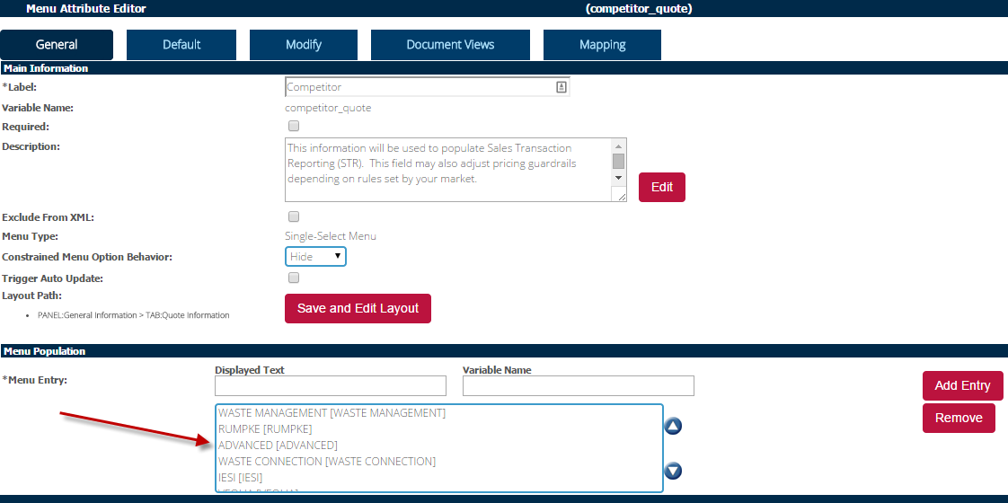

2. Check that the competitor is in the Area Competitors constraint.

Go to Process Definition, Documents, Quote Rules, List and open the constraint entitled ‘Competitors for Area A##’. In the Action (Values to Constrain/Allow) section, click on the Value multi-select list and add any needed competitors.

For example, if you need to add ISEI:

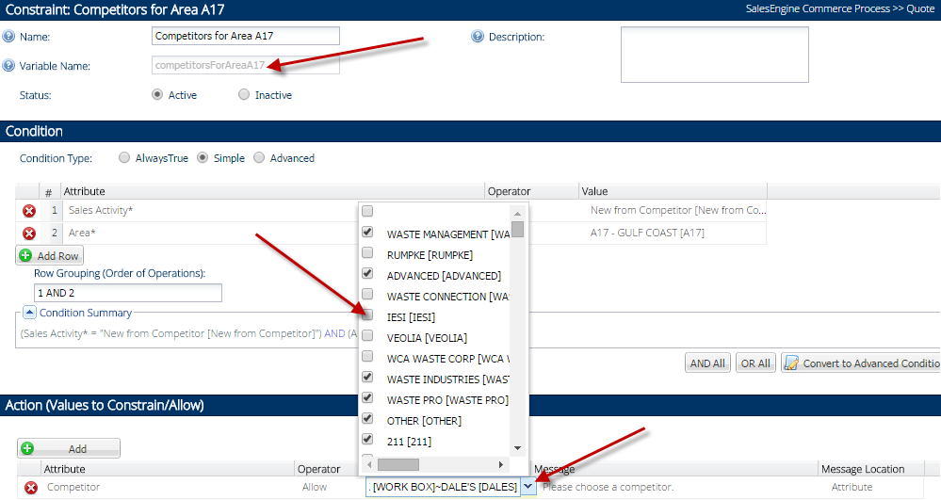

There is an additional step if there is a duplicate competitor name in an Area.  In that case they need to be added to an additional dropdown and another constraint in order to let the user choose the correct competitor code.

# Design

## #426 Competitors missing for Area 49BU 454 Salt Lake City

**Issue/ Design**

Competitors missing for Area 49. See screenshot below of the competitors to add

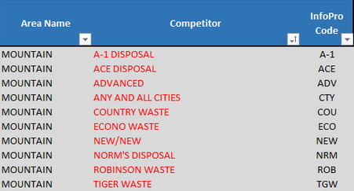

**BI or InfoPro**

No impact. No additional fields or functionality added. All competitors already in InfoPro

## #421 Area 03 Div 3211 need competitor Sanico (SAO) to be added

**Issue/Design**

Sanico (SAO) need to be added to Competitors in Capture. It has already been added to the placemat.

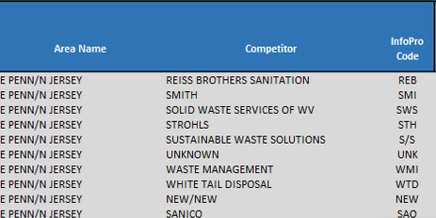

**BI or InfoPro**

No impact. No additional fields or functionality added

## #417 Competitors not in Dropdown list for Area 08

**Issue/Design**

There are serveral competitors missing in the New from Competitor (and probably the other dropdowns) list. Please add the missing competitors below in red.

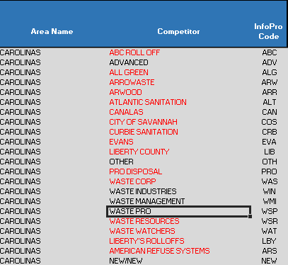

**BI or InfoPro**

No impact. No additional fields or functionality added

## #415 Competitors missing in Capture for Area 38

**Issue**

area competitors on the Placemat for BU333 are missing in Capture. Please add all of the following. *Update: “Other” and “AAA Disposal” are already there.

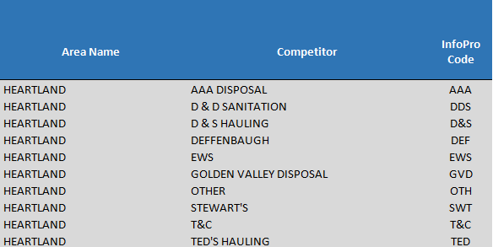

**BI or InfoPro**

No impact. No additional fields or functionality added.

# InfoPro Interface

No new variable should be needed and no existing variables should be repurposed. All competitors already exist in InfoPro.

# Report Changes

NA

# Appendix